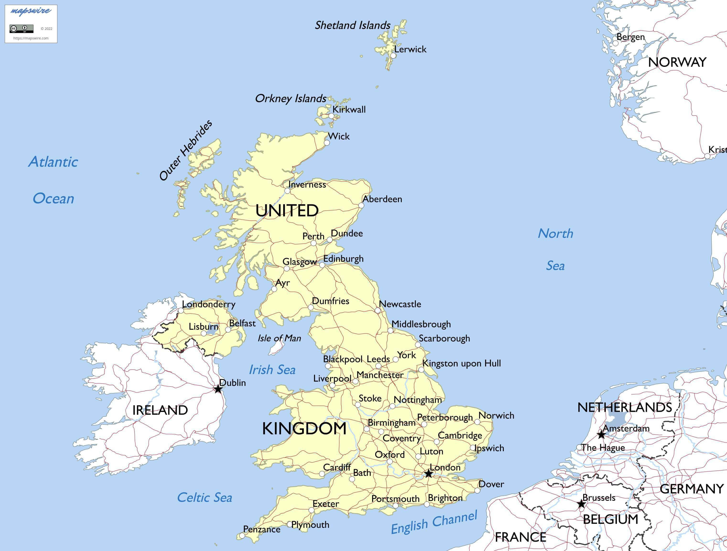

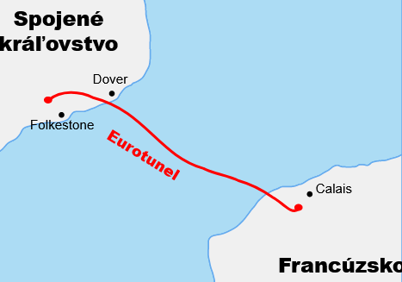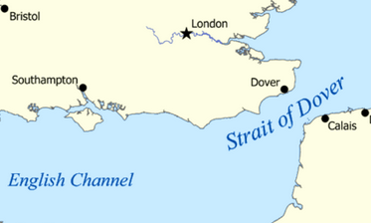

1. **LOCATION and CHARACTERISTICS of Great Britain**

**The United Kingdom of ................. ................... and ..................... ..................... (the UK)**

consists of (........................, ............................., ............................, ...............................)

**Great Britain** comprises ............................, ................................ and ...............................

**POLITICAL SYSTEM:**

........................... ..............................: the monarch exercises their authority in accordance with a constitution and is not alone in decision making **AND**

................................. ......................................... a system of democratic governance of a state.

**HEAD OF STATE**: Monarch: ................................................ Until 2022: ..............................................

Prime Minister: .........................................

**THE FLAG:** called the ............... ...............is made up of 3 crosses symbolizing 3 older national flags**.**

**ANTHEM**: ......................................................

**POPULATION**: .......................million of inhabitants, multiethnic population

**LOCATION:**

**The total area** of the United Kingdom is approximately ...........................square kilometres.

The country occupies the major part of the ................ Isles. It is surrounded by the ........................... Ocean and the ........................ Sea.

**The natural border** the ................... ................... separates Great Britain from ................/continental Europe. ................. of .................. is the [strait](https://en.wikipedia.org/wiki/Strait) at the narrowest part of the [English Channel](https://en.wikipedia.org/wiki/English_Channel). Towns **...................** and **......................** are connected by ferries. The **Channel Tunnel** is the longest underwater .......................... tunnel in the world (50km).

**Neighbour countries**:......................... on the west,.......................... on the southeast.

**LARGEST CITIES:**

**England**:............................................................................................................................

**Wales**:..............................................................................................................................

**Scotland**:.........................................................................................................................

**Northern Ireland**: ............................................................................................................

**RIVERS**: ..the longest river in England.........................................................

**LAKES**: .. the largest is .....................in the Lake District, .............. with a famous creature

**LANDSCAPE**: low hills and plains, with uplands (**Pennines)** and mountainous terrain in the north and west of the country. The [English Lowlands](https://en.wikipedia.org/wiki/English_Lowlands_beech_forests) are in the central and southern regions of the country, the form green rolling hills, where they meet the sea they form white rock exposures such as the [**cliffs of Dover**](https://en.wikipedia.org/wiki/Cliffs_of_Dover)**. The Highlands -** area in Scottland with many[mountain ranges](https://en.wikipedia.org/wiki/Mountain_range) including the highest mountain in the [British Isles](https://en.wikipedia.org/wiki/British_Isles), ............................(1,345m)

**CLIMATE:** has a temperate climate with........... and ............ weather, that changes a lot. The Gulf Stream brings mild winters (temperatures seldom dropping under 0°C)

1. **PARTICULARITIES OF THE COUNTRY:**

**THE BRITISH** are said to have a strong sense of tradition, they are proud of their country, they loved the Queen (the King ?). They admire and support the Royal Family, they often talk about the weather, they drive on the left, i tis said it always rains in the UK, , 40% of people own a pet, even while beeing a member of the EU they kept their currency- The Pound Sterling

**WALES -** country of mystery, beauty and castles

**SCOTLAND** - country full of traditions: playing bagpipes, wearing kilts (pleated knee-length tartan skirt), drinking Scotch whisky, patriots, believe in Nessie

**Holidays- St. patrons Days** - St. Patrick’s Day in Ireland, Guy Fawkes Night

**Christmas-**

**Easter-**

1. **PEOPLE’S LIFESTYLE:**

**tea at 5-**

**sport-**

**schools-**

**housing-**

**free time-**